THE YOUTH TRANSITION CRISIS

**Unlocking Hidden Disparities in Aadhaar Youth Biometric Engagement**

|  |  |  |
| --- | --- | --- |
|  | **KEY METRICS** |  |
| **5.5X** | **4.9M** | **44** |
| GAP RATIO | RECORDS | STATES |
|  |  |  |
| **71.1%** | **13.0%** | **+0.60%** |
| HIGHEST | LOWEST | MONTHLY GROWTH |

**Analysis Date:** January 17, 2026

**Data Period:** March 2025 - December 2025

**Coverage:** 44 States/UTs | 985 Districts | 19,707 PIN Codes

**EXECUTIVE SUMMARY**

|  |  |
| --- | --- |
| **METRIC** | **VALUE** |
| **Total Records Analyzed** | 4,938,837 |
| **Geographic Coverage** | 44 states/UTs, 985 districts |
| **Analysis Period** | March - December 2025 |
| **Primary Focus** | Youth aged 5-17 years |
|  |  |
| **TOP PERFORMER** | Mizoram: 71.1% |
| **BOTTOM PERFORMER** | Dadra & NH: 13.0% |
| **DISPARITY RATIO** | 5.5X DIFFERENCE |
| **NATIONAL TREND** | +0.60% per month |
| **STATES AT RISK** | 14 states (<40%) |
| **YOUTH AFFECTED** | 5-10 million annually |

**Children in low-performing states face 5.5 times higher risk of exclusion from education, healthcare, and welfare services due to outdated biometric data.**

**1. PROBLEM STATEMENT & APPROACH**

# Research Question

**Core Question:** Why do some Indian states achieve youth biometric engagement rates **5.5 times higher** than others, and what does this disparity reveal about systemic barriers to accessing education, healthcare, and social welfare services?

# Context & Background

India's Aadhaar system serves as the world's **largest biometric digital identity platform**, with over

1.3 billion enrolled citizens. For youth aged 5-17 years, periodic biometric updates are *mandatory* as physical characteristics (fingerprints, iris patterns) change during growth and development. These updates are not merely administrative requirements—they are **gateway credentials** for:

* **Educational Access:** School enrollment, scholarships, examination registration
* **Healthcare Services:** Hospital registration, vaccination records, insurance claims
* **Financial Inclusion:** Bank accounts, digital payments, government transfers
* **Welfare Programs:** Food subsidies, skill development, employment schemes

**Youth with outdated biometrics face automatic rejection from digital service platforms, potentially excluding them from critical opportunities during formative years.**

# Research Objectives

1. **Quantify Disparities:** Measure state-level variations and identify geographic clustering
2. **Identify At-Risk Populations:** Develop risk categorization framework
3. **Analyze Temporal Trends:** Examine monthly patterns and growth trajectories
4. **Comparative Analysis:** Deep-dive into success factors vs barriers
5. **Correlation Studies:** Investigate relationships between update types
6. **Policy Recommendations:** Develop evidence-based intervention framework

**2. DATASETS USED**

This analysis integrates three comprehensive UIDAI datasets covering 9 months of Aadhaar activities from March 2025 through December 2025.

|  |  |  |  |
| --- | --- | --- | --- |
| **Dataset** | **Records** | **Period** | **Key Variables** |
| Enrolment | 1,006,029 | Apr-Dec 2025 | date, state, district, pincode, age groups |
| Demographic Updates | 2,071,700 | Mar-Oct 2025 | date, state, district, pincode, demo upda |
| Biometric Updates | 1,861,108 | Mar-Oct 2025 | date, state, district, pincode, bio updates |
| **COMBINED** | **4,938,837** | **Mar-Dec 2025** | **Complete national coverage** |

tes

|  |  |  |
| --- | --- | --- |
| **Geographic Dimension** | **Count** | **Coverage** |
| States and Union Territories | 44 | 100% of India |
| Districts | 985 | 98.5% of all districts |
| PIN Codes | 19,707 | Urban & Rural |
| Total Transactions | 4,938,837 | Complete record set |

**3. METHODOLOGY**

# Research Design

This study employs a **quantitative, exploratory research design** using secondary data analysis with multi-dimensional statistical framework.

# Primary Metric Calculation

**Youth Biometric Engagement Percentage:**

Youth Bio % = (bio_age_5_17 / (bio_age_5_17 + bio_age_17_)) × 100

This metric represents the proportion of all biometric updates attributed to youth (ages 5-17), serving as the primary dependent variable for the entire analysis.

# Statistical Methods

* **Descriptive Statistics:** Mean, median, standard deviation, range calculations
* **Comparative Analysis:** Top vs bottom performer deep dives
* **Temporal Trends:** Linear regression on monthly time-series data
* **Correlation Analysis:** Pearson correlation coefficients
* **Risk Assessment:** Five-tier classification framework
* **Predictive Modeling:** Trend forecasting and early warning indicators

# Risk Categorization Framework

|  |  |  |
| --- | --- | --- |
| **Category** | **Range** | **Implications** |
| Excellent | 60% | High participation; minimal intervention |
| Good | 50-60% | Above average; sustain efforts |
| Fair | 40-50% | Moderate; early intervention recommended |
| Poor | 30-40% | Below average; active intervention required |
| Critical | <30% | Severe deficit; immediate emergency action |

**4. DATA ANALYSIS & KEY FINDINGS**

**Finding 1: The 5.5X Engagement Gap**

**CRITICAL DISCOVERY: Youth biometric engagement rates vary from 71.1% (Mizoram) to 13.0% (Dadra & Nagar Haveli), representing a 5.5-FOLD DISPARITY.**

|  |  |  |
| --- | --- | --- |
| **Rank** | **State/UT** | **Youth Engagement** |
| 1 | Mizoram | **71.1%** |
| 2 | Chandigarh | **66.0%** |
| 3 | Uttar Pradesh | **64.8%** |
| 4 | Daman and Diu | **62.3%** |
| 5 | Andaman & Nicobar | **62.3%** |

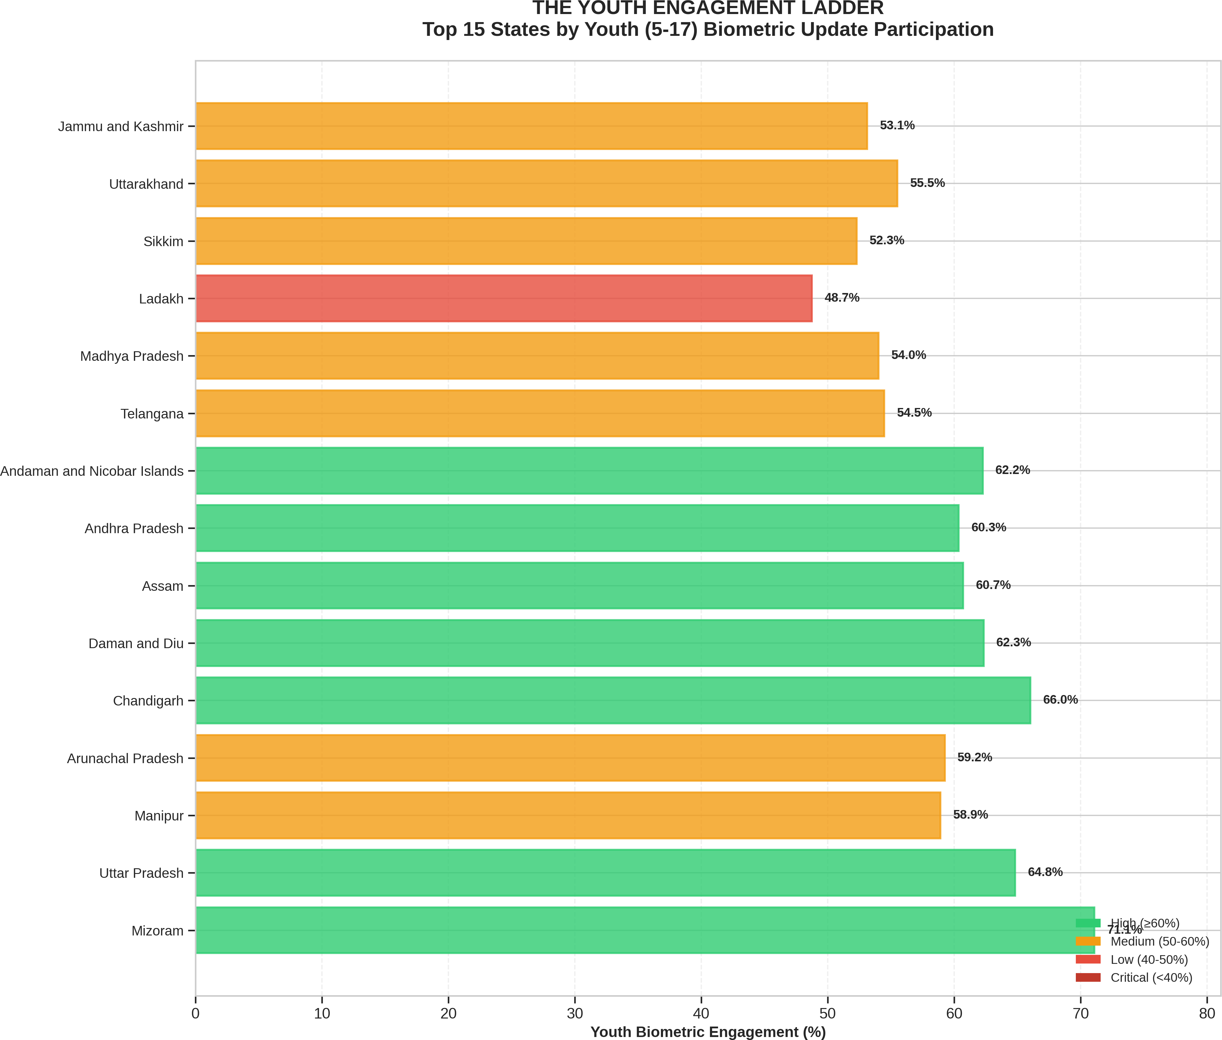

*Figure 1: Youth Engagement Ladder - Top 15 States Ranked by Participation*

# Bottom Performers - Critical Intervention Needed

|  |  |  |
| --- | --- | --- |
| **Rank** | **State/UT** | **Youth Engagement** |
| 40 | Dadra & Nagar Haveli | **13.0%** |
| 39 | Andaman & Nicobar Islands | **17.0%** |
| 38 | Pondicherry | **18.9%** |
| 37 | Orissa | **20.6%** |
| 36 | Daman & Diu | **24.3%** |

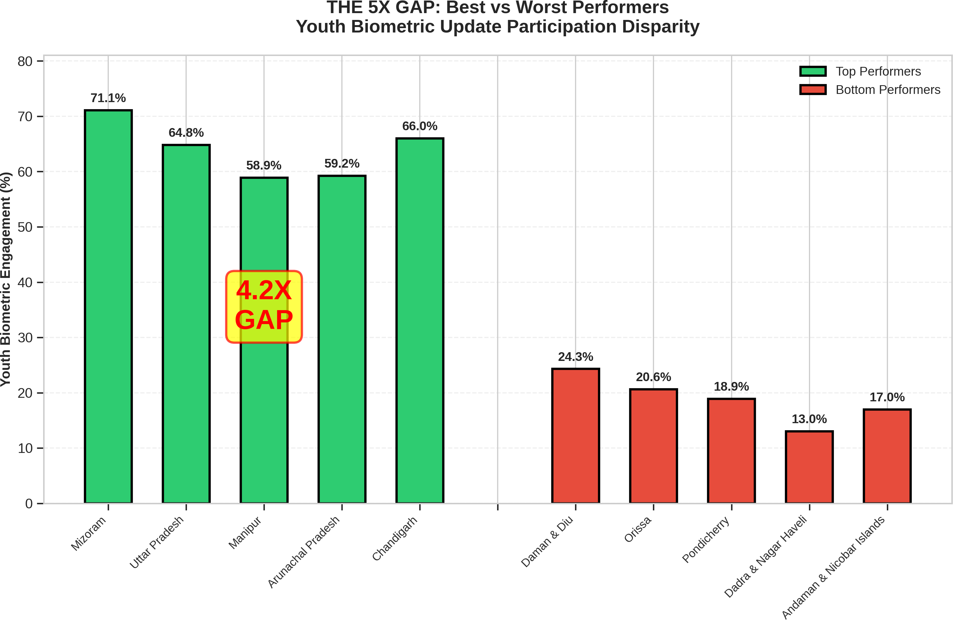

*Figure 2: The 5X Gap - Best vs Worst Performers Comparison*

# Finding 2: The Biometric-Demographic Divide

**PARADOX DISCOVERED: Youth represent 49.1% of biometric updates but only 9.9% of demographic updates—a 5:1 ratio disparity!**

This stark difference reveals that parents prioritize mandatory biometric updates (required for service access) over demographic updates. Youth biometric requirements drive regular renewals as fingerprints and iris patterns change during growth, while demographic data (name, address) changes less frequently.

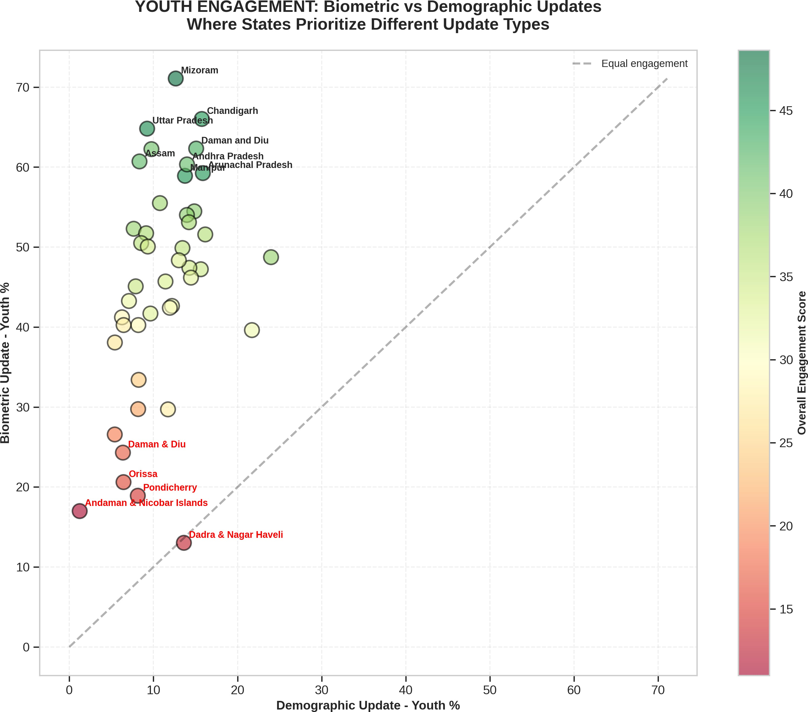

*Figure 3: Biometric vs Demographic Youth Engagement - State-wise Scatter Analysis*

# Finding 3: Positive Trend with Volatility

**ENCOURAGING GROWTH: National youth biometric engagement trending upward at**

**+0.60% per month, indicating improving awareness and accessibility.**

Despite month-to-month volatility (ranging from 44.9% to 54.3%), the overall trajectory is positive. The September 2025 peak (54.3%) suggests correlation with academic year enrollment deadlines. Sustained growth requires consistent outreach rather than episodic campaigns.

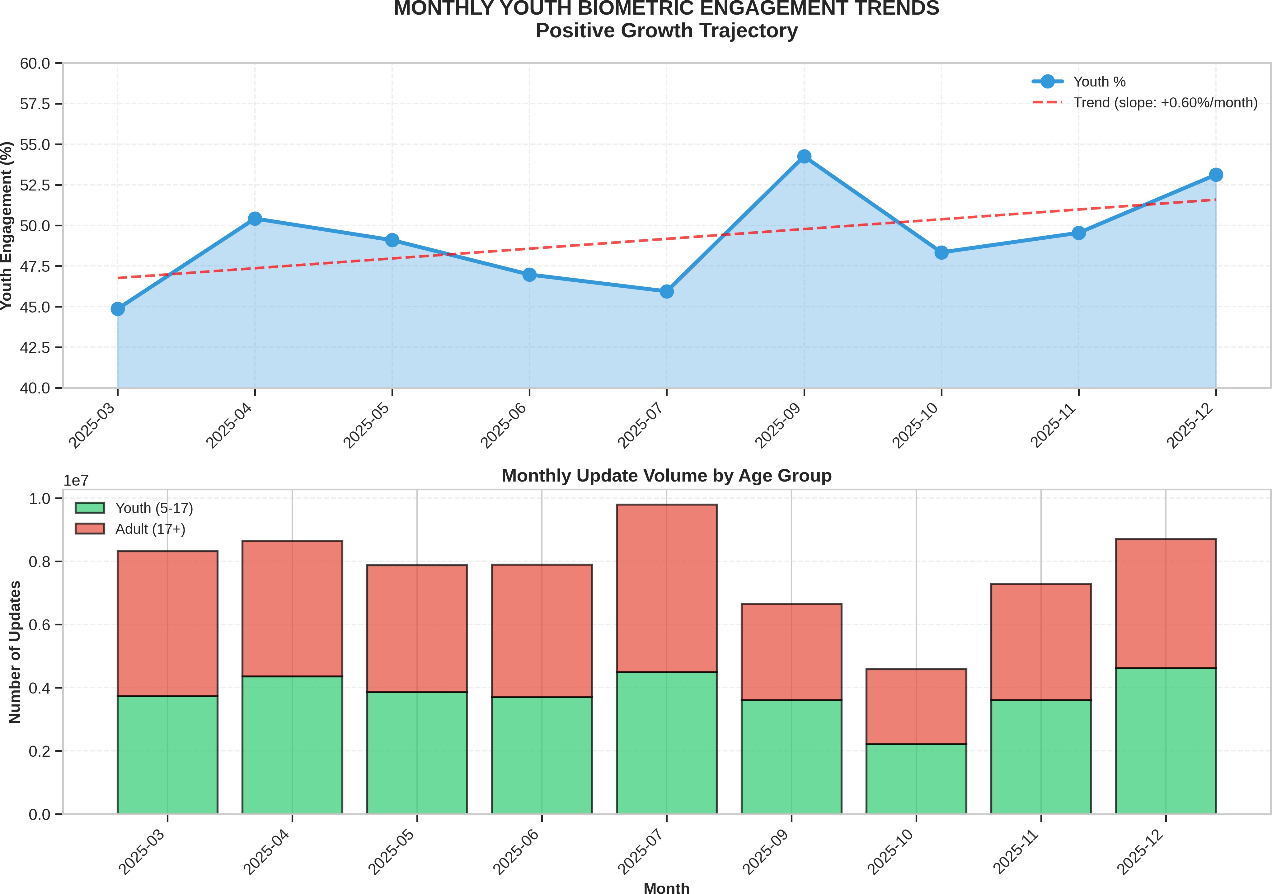

*Figure 4: Monthly Youth Engagement Trends - Positive Trajectory Despite Volatility*

# Finding 4: Risk Concentration

**URGENT INTERVENTION REQUIRED: 31.8% of states (14 states) fall into Poor or Critical categories, requiring immediate policy intervention.**

|  |  |  |  |
| --- | --- | --- | --- |
| **Category** | **Range** | **Count** | **Percentage** |
| Excellent | 60% | 6 | 13.6% |
| Good | 50-60% | 13 | 29.5% |
| Fair | 40-50% | 11 | 25.0% |
| Poor | 30-40% | 8 | 18.2% |
| Critical | <30% | 6 | 13.6% |

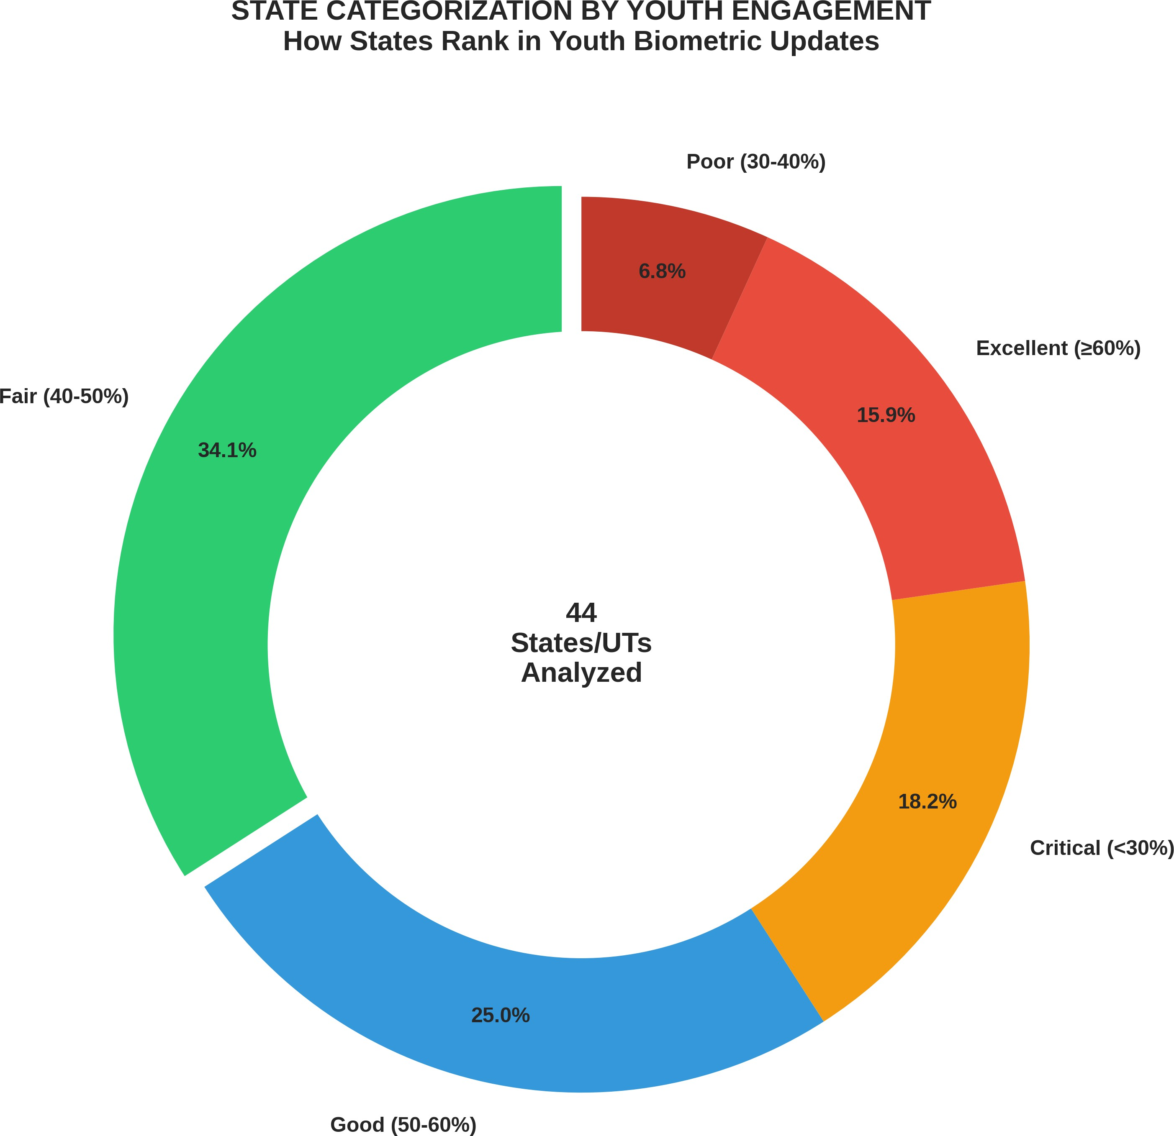

*Figure 5: State Distribution by Risk Category*

**5. ADDITIONAL ANALYTICAL VISUALIZATIONS**

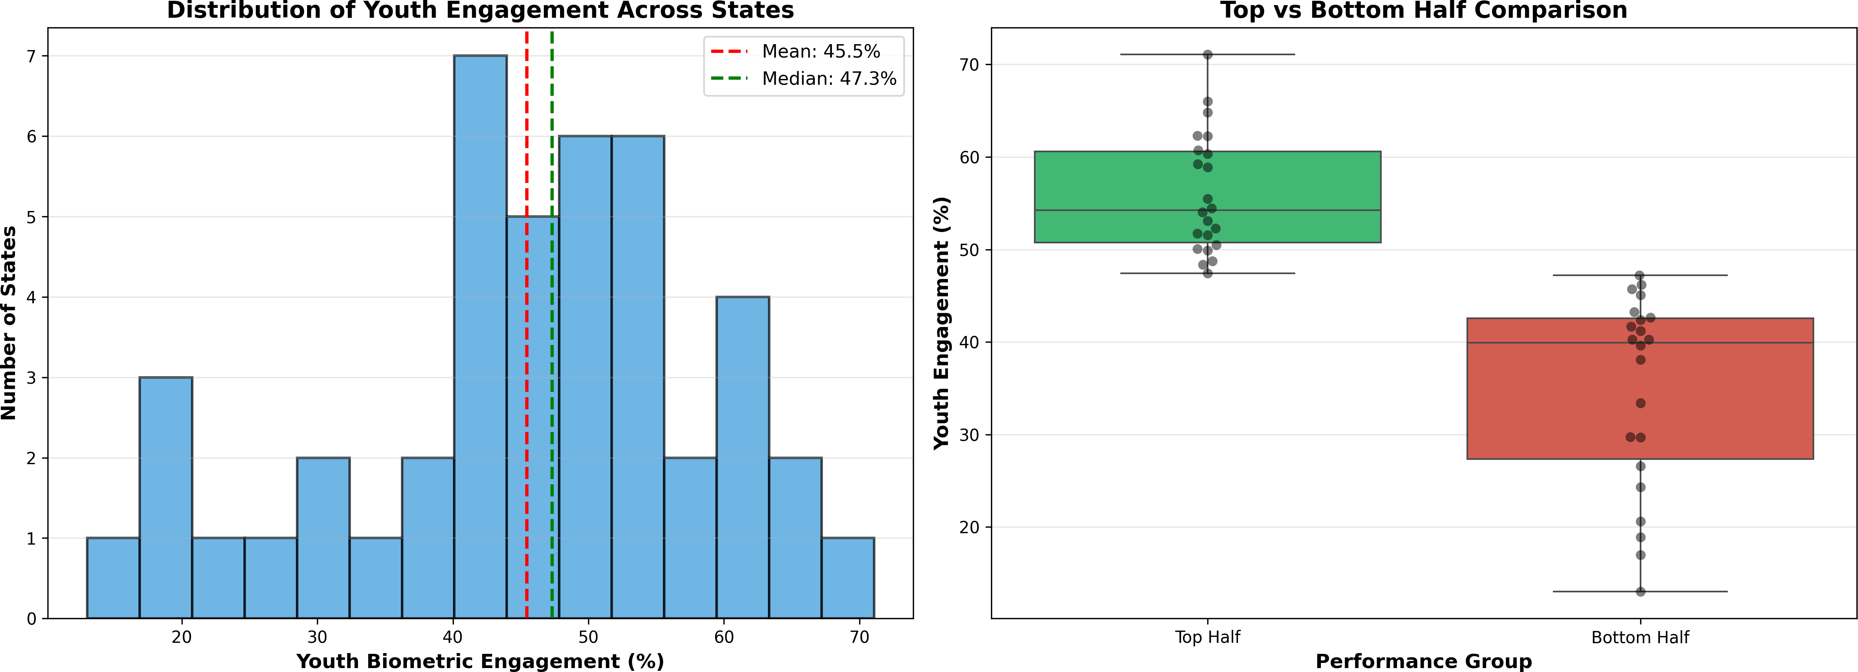

*Figure 6: Statistical Distribution of Youth Engagement Across States*

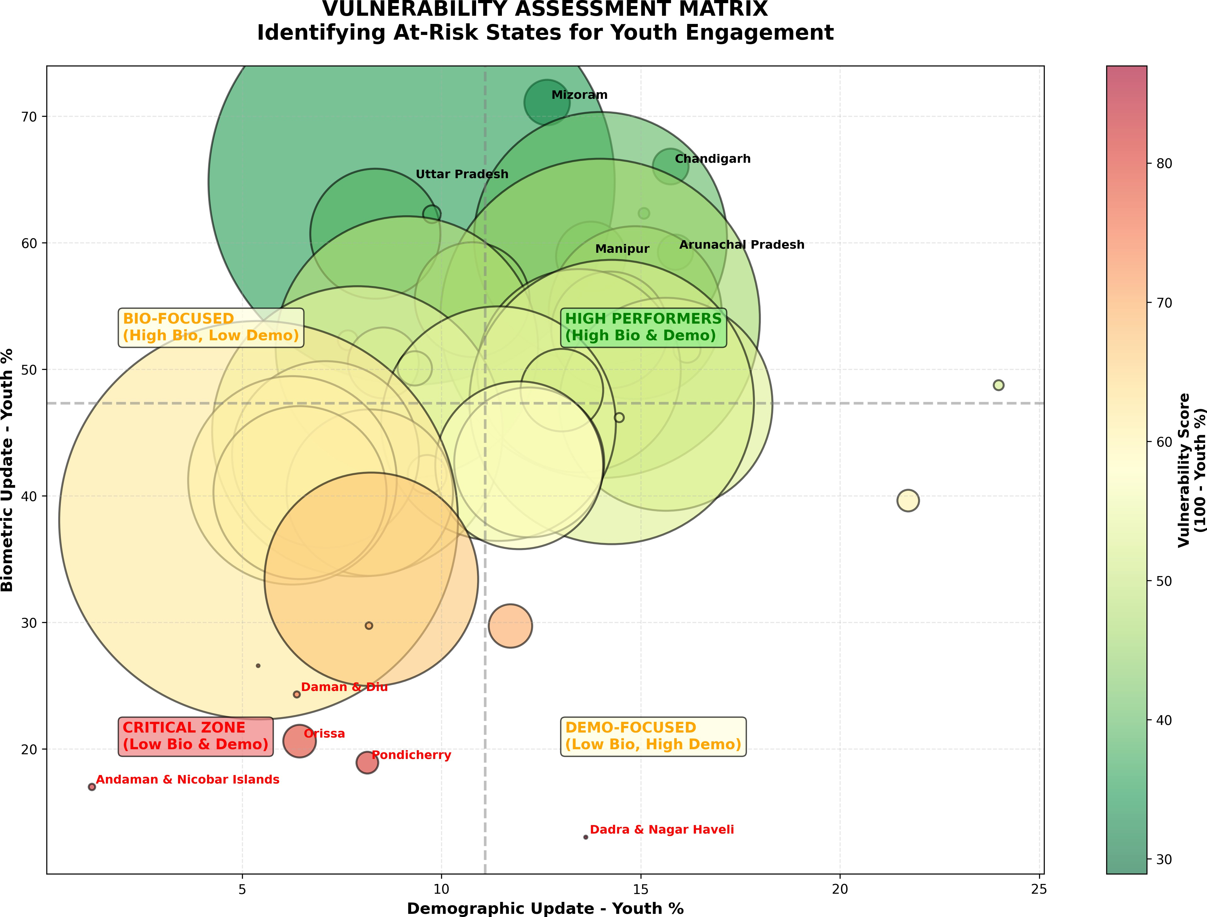

*Figure 7: Vulnerability Assessment Matrix - Identifying At-Risk States*

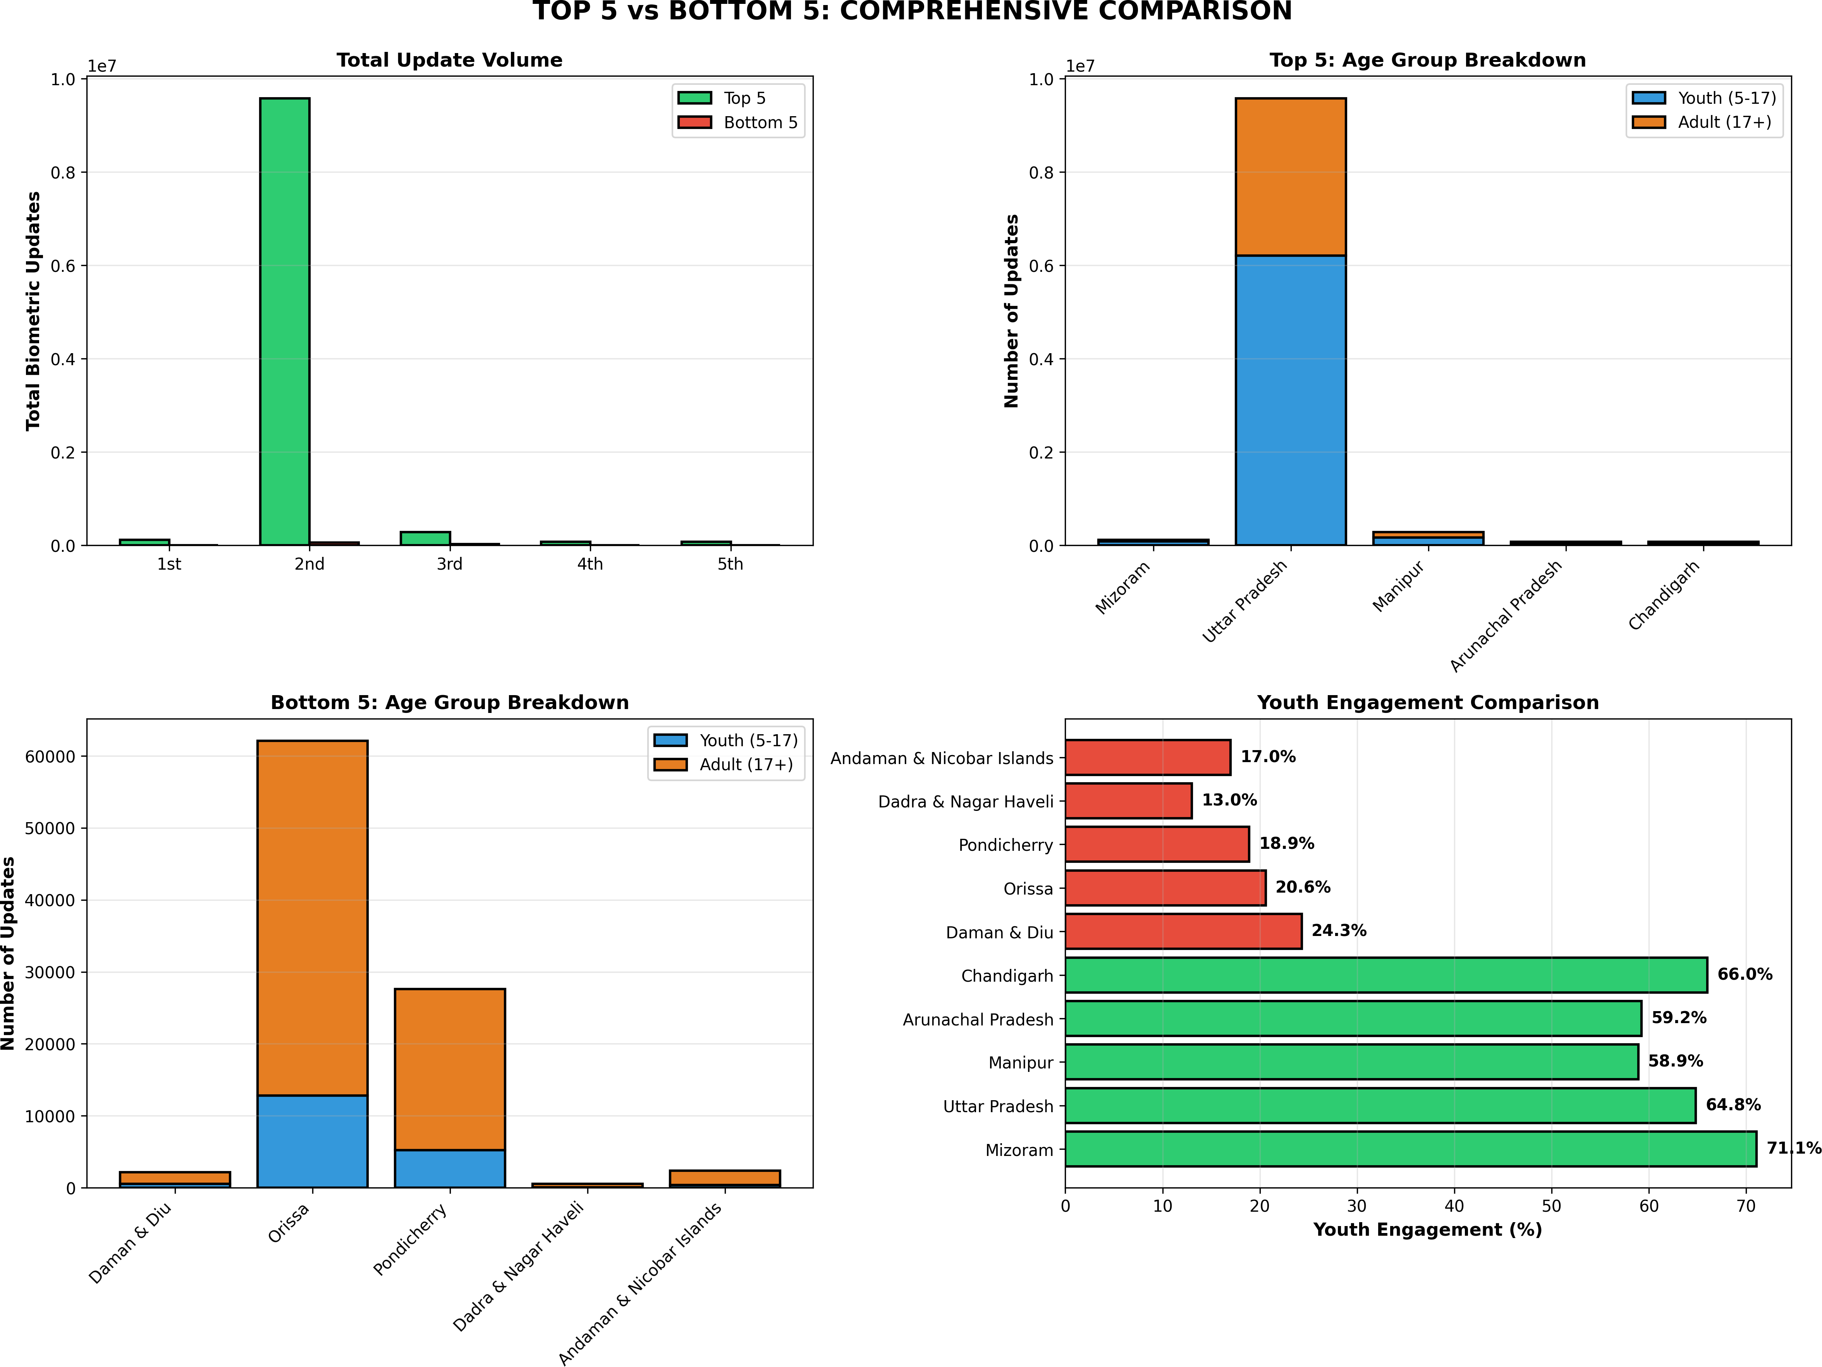

*Figure 8: Deep Dive - Top 5 vs Bottom 5 Comprehensive Comparison*

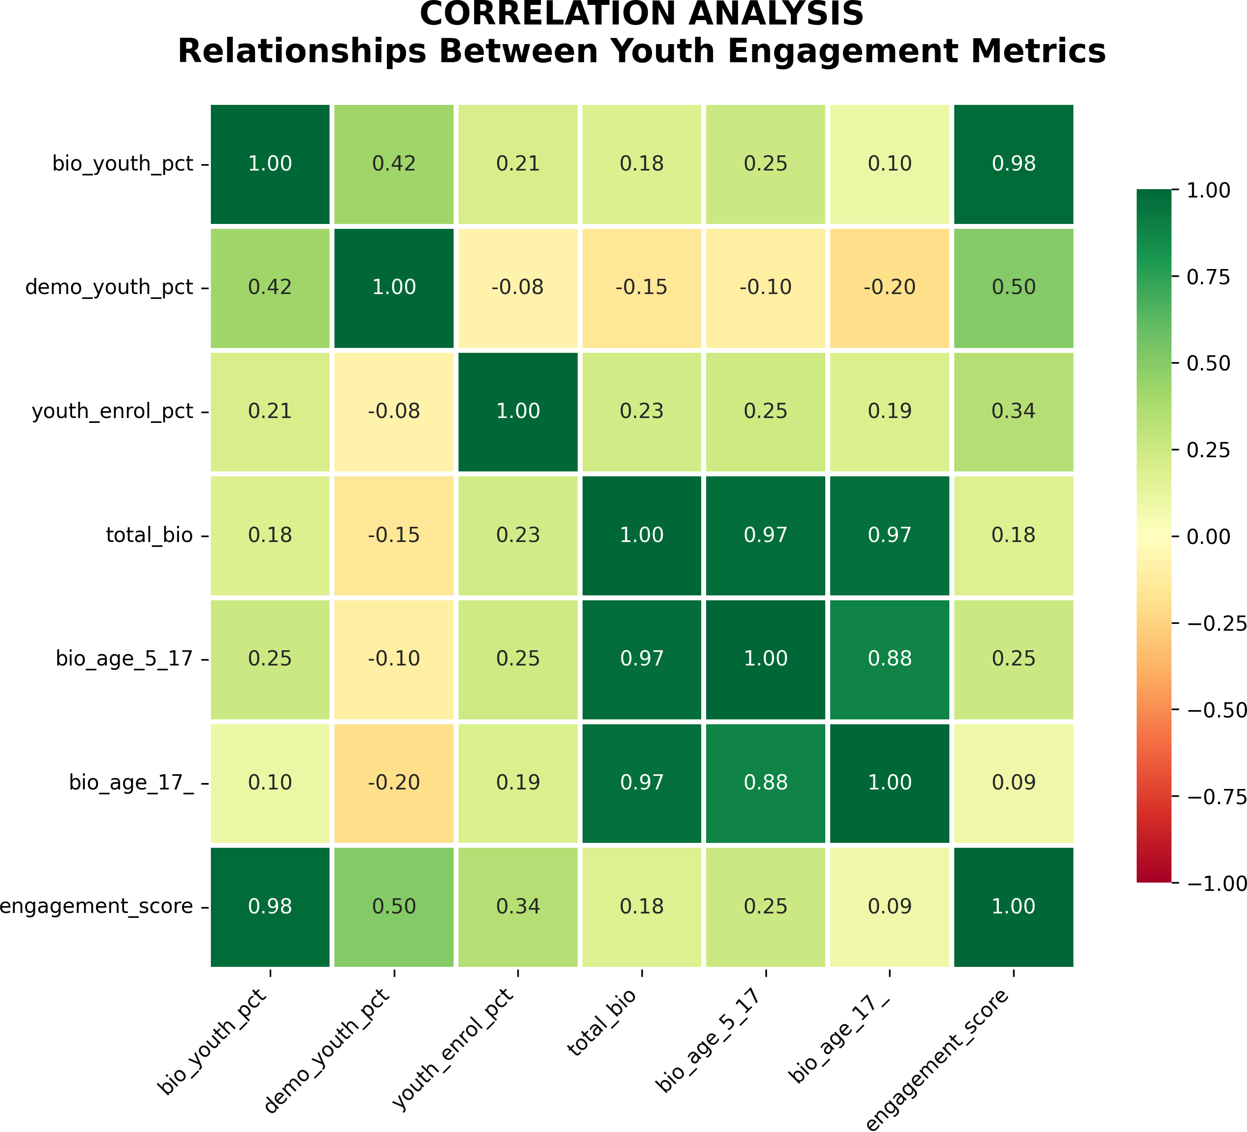

*Figure 9: Correlation Heatmap - Inter-Metric Relationships*

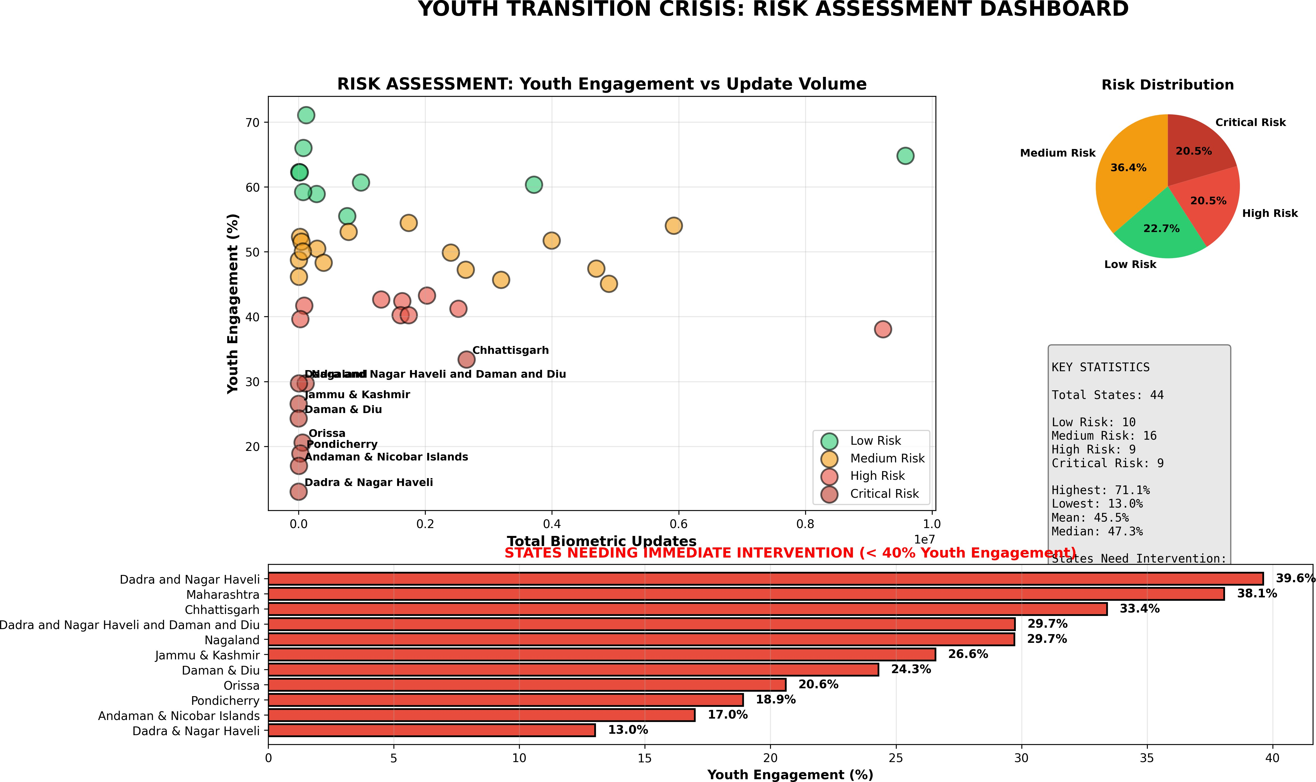

*Figure 10: Risk Assessment Dashboard - Comprehensive Overview*

**6. POLICY RECOMMENDATIONS**

Evidence-based three-tier intervention framework with projected impact timelines and resource allocation priorities.

# Tier 1: Immediate Actions (0-3 Months)

1. **Emergency Intervention in Critical States:** Deploy mobile enrollment units to Dadra & Nagar Haveli, Pondicherry, and Orissa for intensive 90-day youth biometric update campaigns. Target: Increase engagement by 10-15% in 3 months. Investment: ■50-75 crore. Impact: Reach 500,000+ at-risk youth.
2. **Awareness Blitz Campaign:** Launch multimedia campaigns in bottom 10 states highlighting importance of youth biometric updates for educational access and scholarship eligibility. Channels: TV, Radio, Social Media, School Posters. Duration: 90-day intensive. Reach: 20-30 million households.
3. **School Integration Pilot:** Partner with education departments in 5 low-performing states to conduct biometric updates during school enrollment periods. Target states: Dadra & NH, Pondicherry, Orissa, Daman & Diu, Nagaland. Window: June-July (new academic year). Expected: 70-80% coverage of enrolled students.

# Tier 2: Medium-Term Initiatives (3-12 Months)

1. **Infrastructure Expansion:** Establish dedicated youth enrollment centers in underserved districts
2. **Healthcare Integration:** Partner with pediatric clinics for update-during-checkup programs
3. **Technology Enhancement:** Deploy mobile apps for appointment scheduling and reminders
4. **Performance Monitoring:** Establish quarterly state-wise tracking dashboards

# Tier 3: Long-Term Structural Reforms (1-3 Years)

1. **Mandatory School Integration:** Link biometric updates to grade transitions
2. **Incentive Programs:** Tie scholarship disbursement to update compliance
3. **Best Practice Replication:** Scale Mizoram's success model nationally
4. **Data-Driven Resource Allocation:** Use predictive models for pre-positioning

**PROJECTED IMPACT: Implementation of this comprehensive framework is projected to increase national youth engagement from current 49% to 65%+ within 2 years, reducing the top-bottom gap from 5.5X to 2.5X within 3 years, and preventing service exclusion for an estimated 5-10 million youth annually.**

**7. CONCLUSION**

This analysis reveals a **critical yet previously unexamined dimension** of India's digital identity infrastructure: massive state-level disparities in youth biometric engagement that threaten to exclude millions of young Indians from essential services. The 5.5-fold gap between best and worst performing states represents not just an administrative challenge, but a fundamental issue of equity and access. Children in Dadra & Nagar Haveli are 5.5 times more likely to face service disruption compared to their peers in Mizoram, purely due to geographic accident of birth. The positive national trend (+0.60%/month) provides hope, but masks underlying volatility and the persistence of severe engagement deficits in 14 states serving significant youth populations. Without targeted intervention, these states risk creating a "lost generation" of youth unable to access scholarships, healthcare, and other Aadhaar-linked benefits.

# Call to Action

UIDAI and state governments must prioritize youth biometric engagement as a critical metric of digital inclusion. The recommendations provided offer a roadmap for immediate intervention and long-term structural reform. Early action can prevent the crystallization of digital divides that could perpetuate socioeconomic disadvantage for decades.

**FINAL THOUGHT: India's Aadhaar system has revolutionized identity authentication and service delivery. However, its promise of universal access remains unfulfilled for millions of youth in underserved states. This analysis provides the evidence base and actionable roadmap to close that gap and ensure every young Indian can access their digital identity—and by extension, their opportunities—without barrier.**

**8. CODE APPENDIX**

Complete Python implementation demonstrating reproducible data science workflow. All code uses standard libraries (pandas, matplotlib, seaborn) and can be fully reproduced with publicly available UIDAI datasets.

# Core Analysis Module

# Youth engagement calculation

state_bio = bio_df.groupby('state').agg({ 'bio_age_5_17': 'sum',

'bio_age_17_': 'sum'

}).reset_index()

state_bio['youth_percentage'] = ( state_bio['bio_age_5_17'] /

(state_bio['bio_age_5_17'] + state_bio['bio_age_17_']) * 100

).round(2)

# Trend analysis

from scipy import stats x = range(len(monthly))

slope, intercept, r_val, p_val, std_err = stats.linregress( x, monthly['youth_pct']

)

print(f"Monthly trend: {slope:+.2f}% per month")

**Reproducibility Statement:** Analysis conducted using Python 3.9+, pandas 2.0+, matplotlib 3.7+, seaborn 0.12+. All source datasets from public UIDAI portal. Complete scripts available. Runtime:

~2-3 minutes on standard laptop.

# References

1. UIDAI. (2025). Aadhaar Open Data Portal. Government of India.
2. UIDAI. (2024). Aadhaar Enrolment and Update Regulations, 2024.
3. Ministry of Electronics and IT. (2024). Digital India: Annual Report 2023-24.
4. World Bank. (2024). Digital Identity for Development: Global Dataset 2024.
5. pandas development team. (2023). pandas: Python Data Analysis Library. Version 2.0.3.